# CHAPTER 1

Introduction to Domain

Computers and Internet are the most brilliant gifts of science. Internet provides better way of

communication and interaction.

* As we all know that in the present world every facility are available on internet as shopping, banking etc.. Then why not FINDING BEST HOSTEL IN YOUR NEARBY THAT SUITS YOU?

WHY THIS DOMAIN?

* In this present world of technology, it is required to construct a way by which people can search Hostels & PGs available to them across the city.
* This application is useful in a way to that people can get best possible reviews of hostels, PGs by users living there instead of getting fake reviews by brokers.

PURPOSE OF OUR DOMAIN

* There are some problems that are faced by the people to find hostels across city manually:
* Much time and money required.
* Hesitation, as some people doesn’t like to talk to strangers.
* Fear of getting fooled by the local agents.
* Thus, for these types of problems we thought that through this My Hostel application we could help people to come out from their hesitation & fear.

**CHAPTER 2**

**What is REVERSE ENGINEERING??**

**Reverse engineering** is the process of collecting data from a piece of equipment, object or system through the analysis of its structure, function and operation, often when there is no digital data available to analyze. It often involves deconstructing an object and analyzing its workings in detail.

Basically, Reverse Engineering is a systematic methodology for analyzing the design of an existing device or system, either as an approach to study the design or as a prerequisite for re-designs.

The purpose of Reverse Engineering is to understand how and why a current design has come to be. Most often this task is completed on physical products that can be taken apart, examined and put back together for continued testing. These same Reverse Engineering procedures are also useful in deciphering chemical compounds, industrial procedures, manufacturing processes and computer programs. Reverse Engineering is often chosen by engineers or design teams who aim to build a competitive or superior product to one that is currently on the market. In the end, the goal is to save time and gain insight into how others have approached similar design challenges. There is no need to reinvent the wheel if a successful design already exists and can simply be improved upon. Dim and little explain reverse engineering as ‘examining competitive or similar or prior products in great detail by dissecting them or literally taking them apart.

* + 1. **Summary of Reverse Engineering:-**

For reverse engineering I have taken websites listed below:

* hostels.com

I have researched for the websites or any application which can be similar to my domain. Basically I found websites listed above. I started to disassemble every component which were in the websites. In the list some are internationals websites and some are locals.

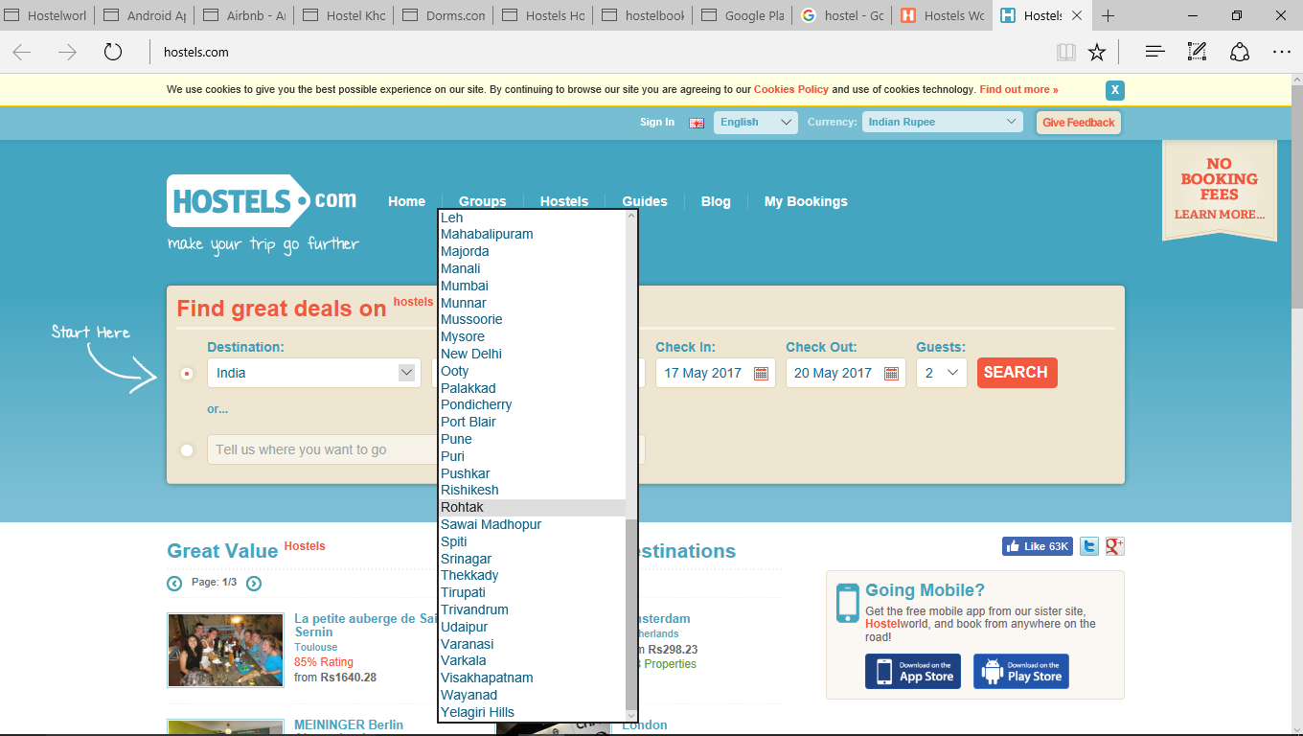

**[Fig 2.1(a) www.hostels.com]**

Hostels.com website seems to have big collection of hostels across the globe including almost all the countries, but it fails to give service to small towns like Rajkot city from Gujarat state, which we tried to cover in My Hostel app.

And in that I found the list of different online hostel booking websites and their native Android apps on Google Playstore. Below are mentioned the pictures of each website with native Android App Screenshot:

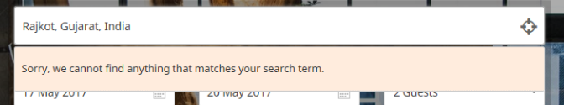

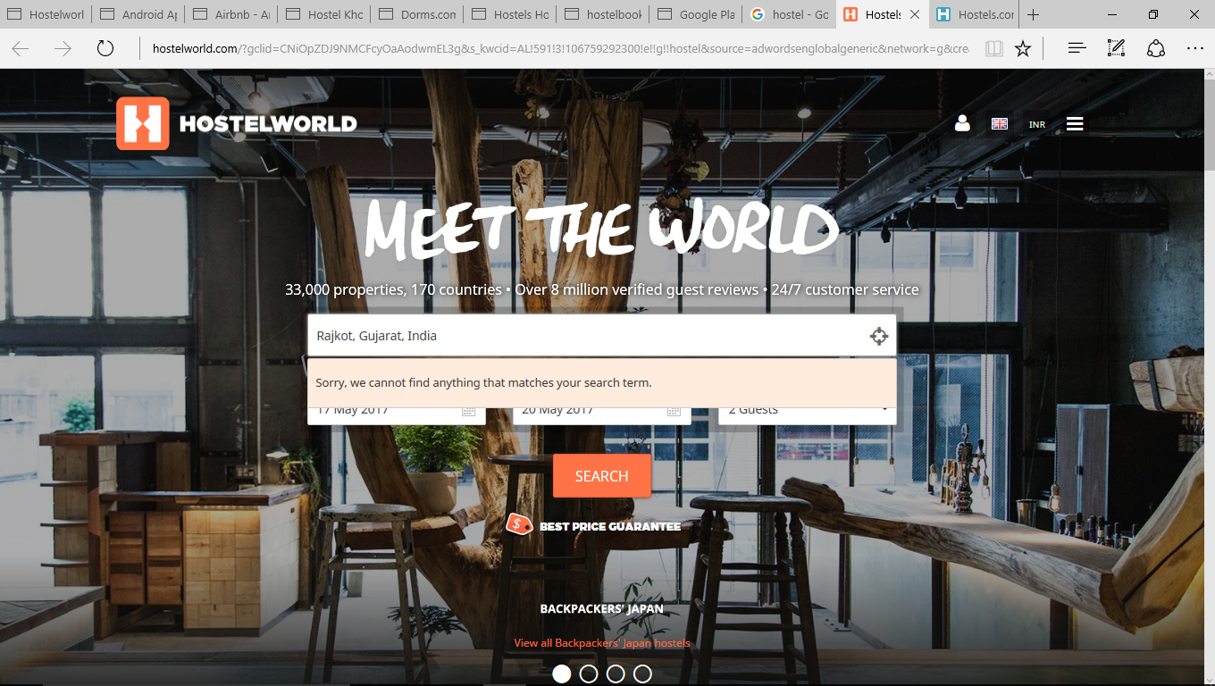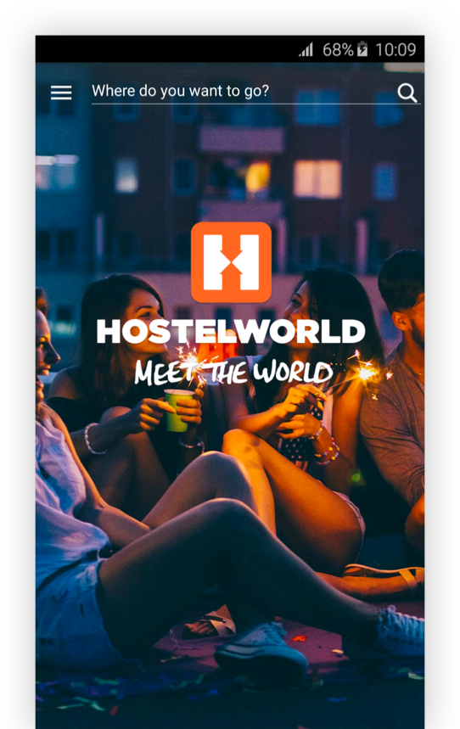

**[Fig 2.1(b)** [**www.hostelworld.com**](http://www.hostelworld.com) **website and its Android App]**

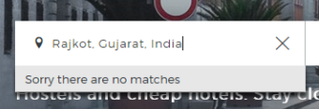

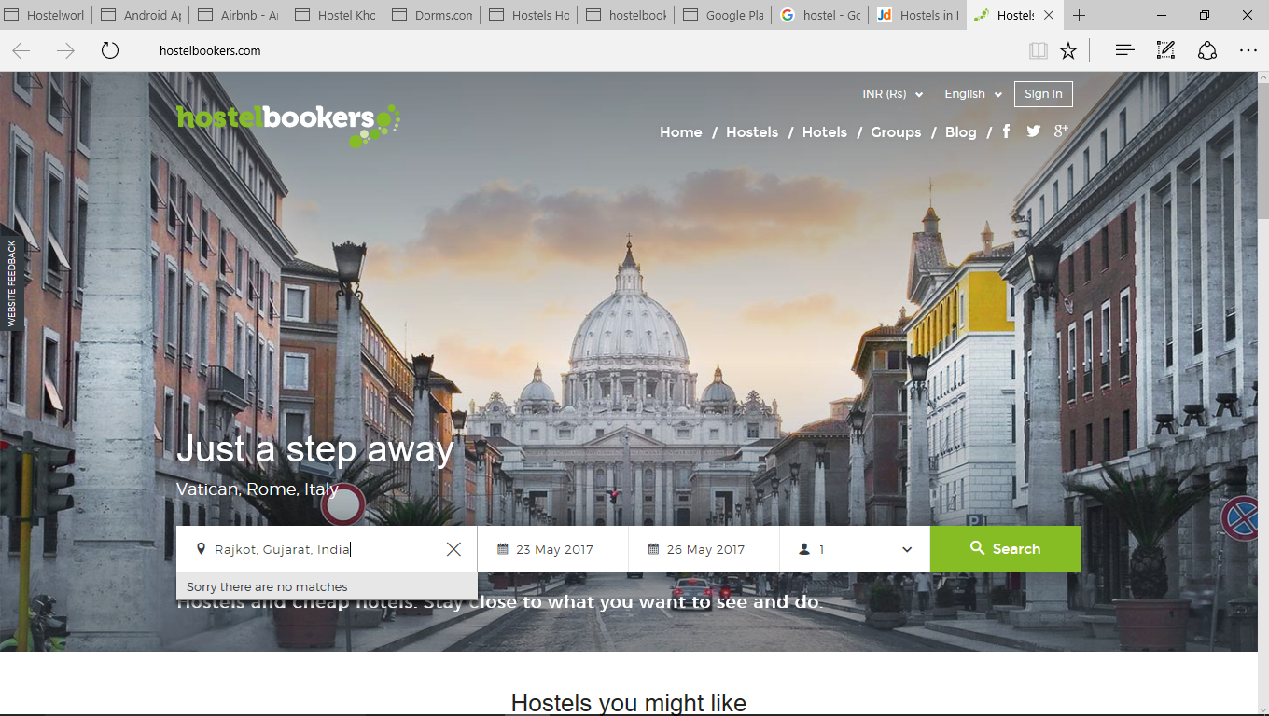

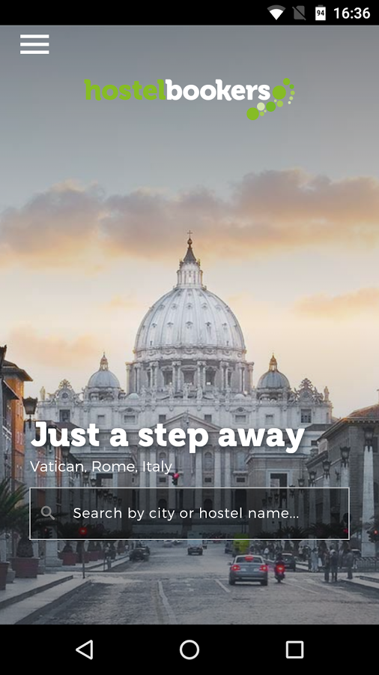

**[Fig 2.1(c)** [**www.hostelbookers.com**](http://www.hostelbookers.com) **website and its Android app]** 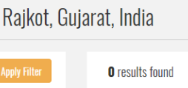

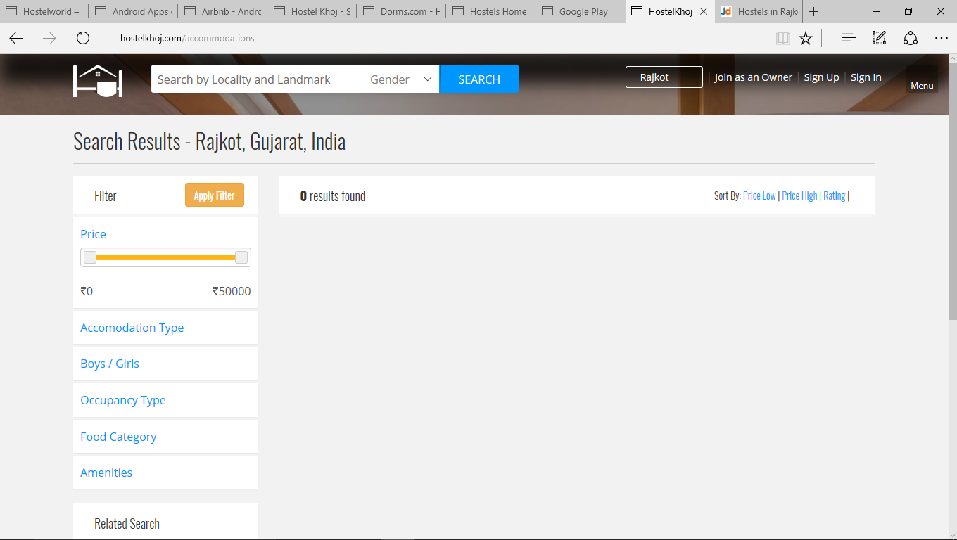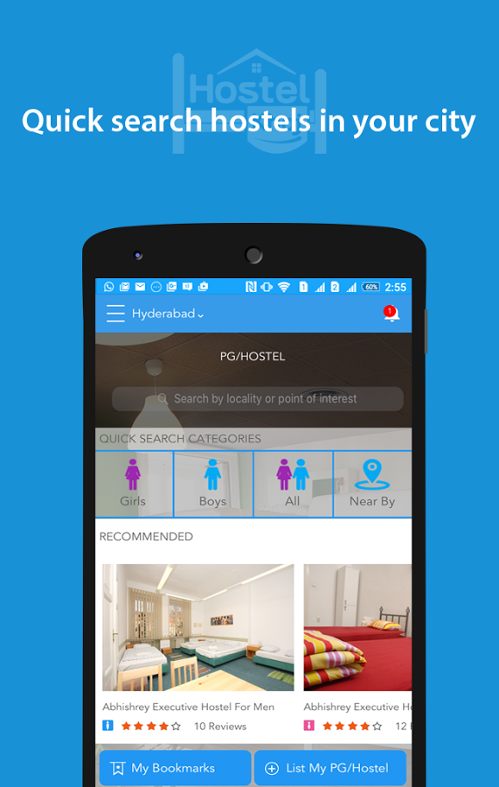

**[Fig 2.1(d)** [**www.hostelkhoj.com**](http://www.hostelkhoj.com) **website and its Android App]**



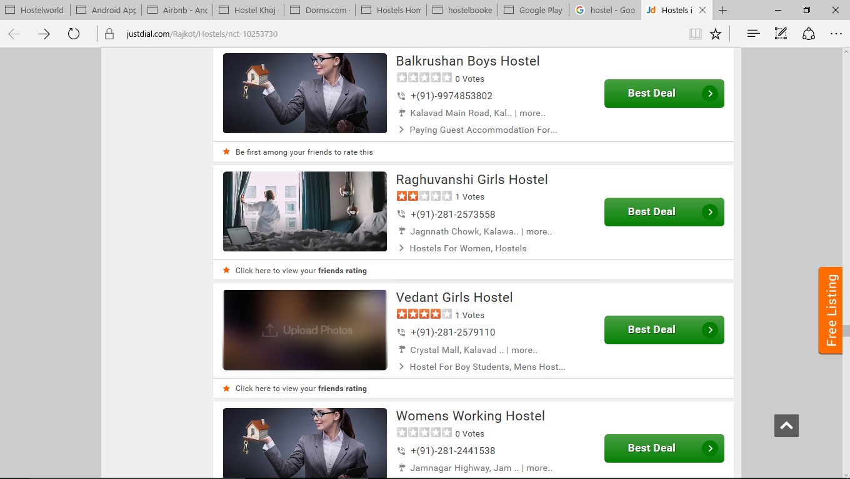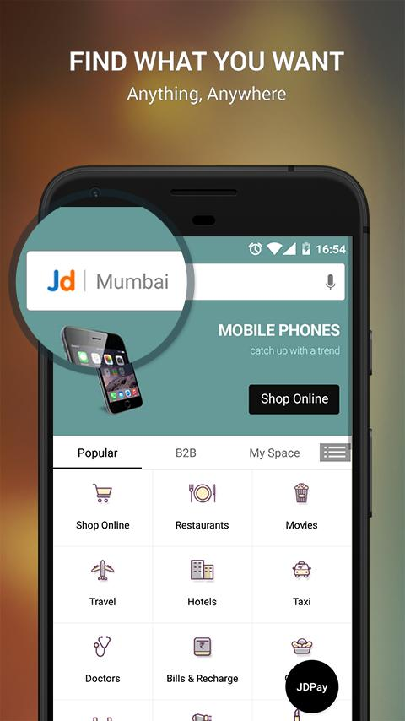

**[Fig 2.1(e)** [**www.justdail.com**](http://www.justdail.com) **website and its Android app]**

As shown above, we have considered Rajkot city from Gujarat state. Considering the fact that Rajkot city is not one of the biggest city of the country. Rajkot is small town that we are taking here for example.

First of all, biggest of the names in the field, hostels.com. They don’t even have Rajkot name on their search bar, which is the biggest drawback for locals here at Rajkot.

Almost all the big names fails to deliver hostels to the Rajkot city locals, which are shown below,

* **hostelworld.com**
* **hostelbookers.com**
* **hostelkhoj.com**

Now talking about Justdail.com, they almost have all of the facilities available to the Rajkot city, they also have some data about hostels available in the Rajkot city. They don’t have correct data about desired hostels, some of them doesn’t have contact details of the hostels, they fail to deliver photos of desired hostels which user want to have overview.

We at My Hostel, will give proper review to the user about hostels, we will verify hostels and upload real world photos, not like creative photoshoped photos shown at justdail.com, we will give proper contact details to the user.

* 1. **Modification in Canvases based on Reverse Engineering**

**Exercise(AEIOU / Empathy / Ideation / PDC)**

* + 1. **AEIOU Canvas Image & Description**

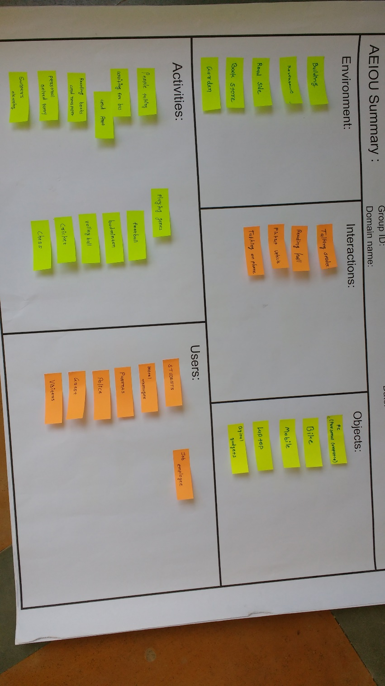

Fig.2.2.1(a)

**Activities:**

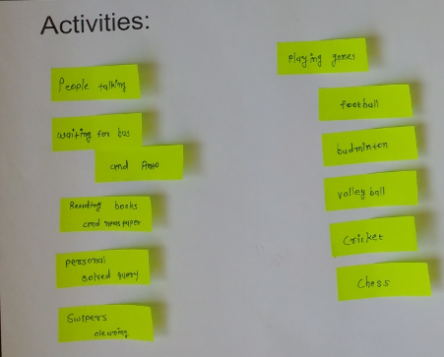

Fig.2.1.1(b)

Various activities are:

* People talking
* Waiting for bus and auto
* Reading books and news paper
* Personal solved query
* Swipers cleaning
* Playing games: Football

Badminton

Volleyball

Cricket

Chess

**Environment:**

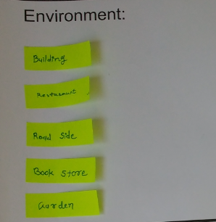

Fig.2.1.1(c)

Components of environment are:

* Buildings
* Restaurants
* Road side
* Book stores
* Gardens
* Provision stores
* Hotels for quick snacks
* Schools, College, Tuition classes etc

**Interactions:**

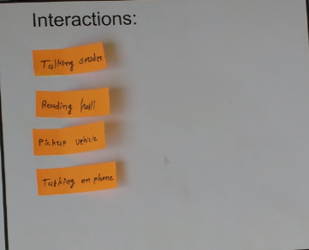

Fig.2.1.1(d)

* Interactions are:
* At Hostel: Students, Workers at hostel, Trusty of hostel etc.
* Outside Hostel: Laundry boys, Tiffinwalas, Milkmen, Pickup vehicles etc.

**Objects:**

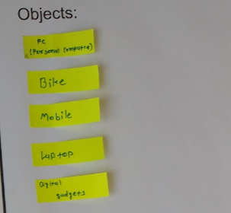

Fig.2.1.1(e)

* Server
* Mobile phones
* Notepad++ or Dreamweaver
* Operating system
* Storage devices
* Laptop
* Desktop computer
* Tablets

**Users:**

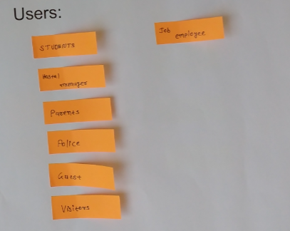

Fig.2.1.1(f)

* Admin: Hostel managers, Service providers
* Students, Senior citizens, Parents, Job employees
* Guest
* Visitors
  + 1. **EMPATHY CANVAS AND DESCRIPTION**

User Empathy canvas is used to help in the discussion about the needs a user has. Using it allows you to focus on what was observed, and what can be inferred about your different user groups’ beliefs and emotions

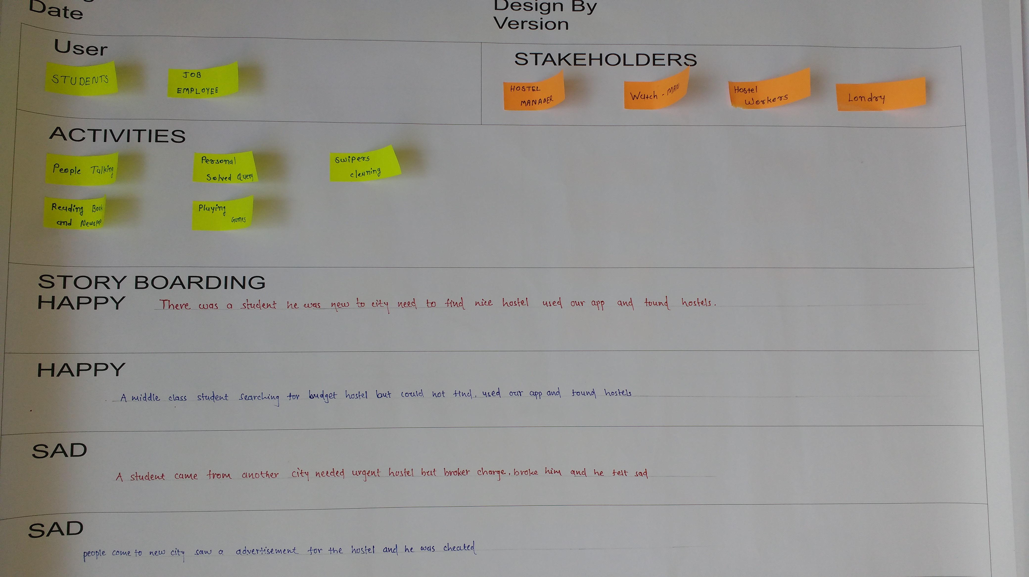

Fig.2.2.2(a)

The users involved in Empathy mapping canvas are;

* + - Students
    - Job employees

The stakeholders in Empathy mapping canvas are;

* + - Hostel manager, Workers at hostel
    - Laundry boys, Tiffinwalas, Milkmen

We wrote some Happy and Sad stories in Empathy mapping canvas by putting ourselves in that

situation so that we come to know that which kind of problems we suppose to face

by this application.

**2.2.3 IDEATION CANVAS IMAGE AND DESCRIPTION**

An ideation canvas is a rough whiteboard where ideas can be stretched into any limits or dimensions. Ideation session is not aimed at finding solutions to the defined problem. But to define the best possible problem and stretch out its possible scope.

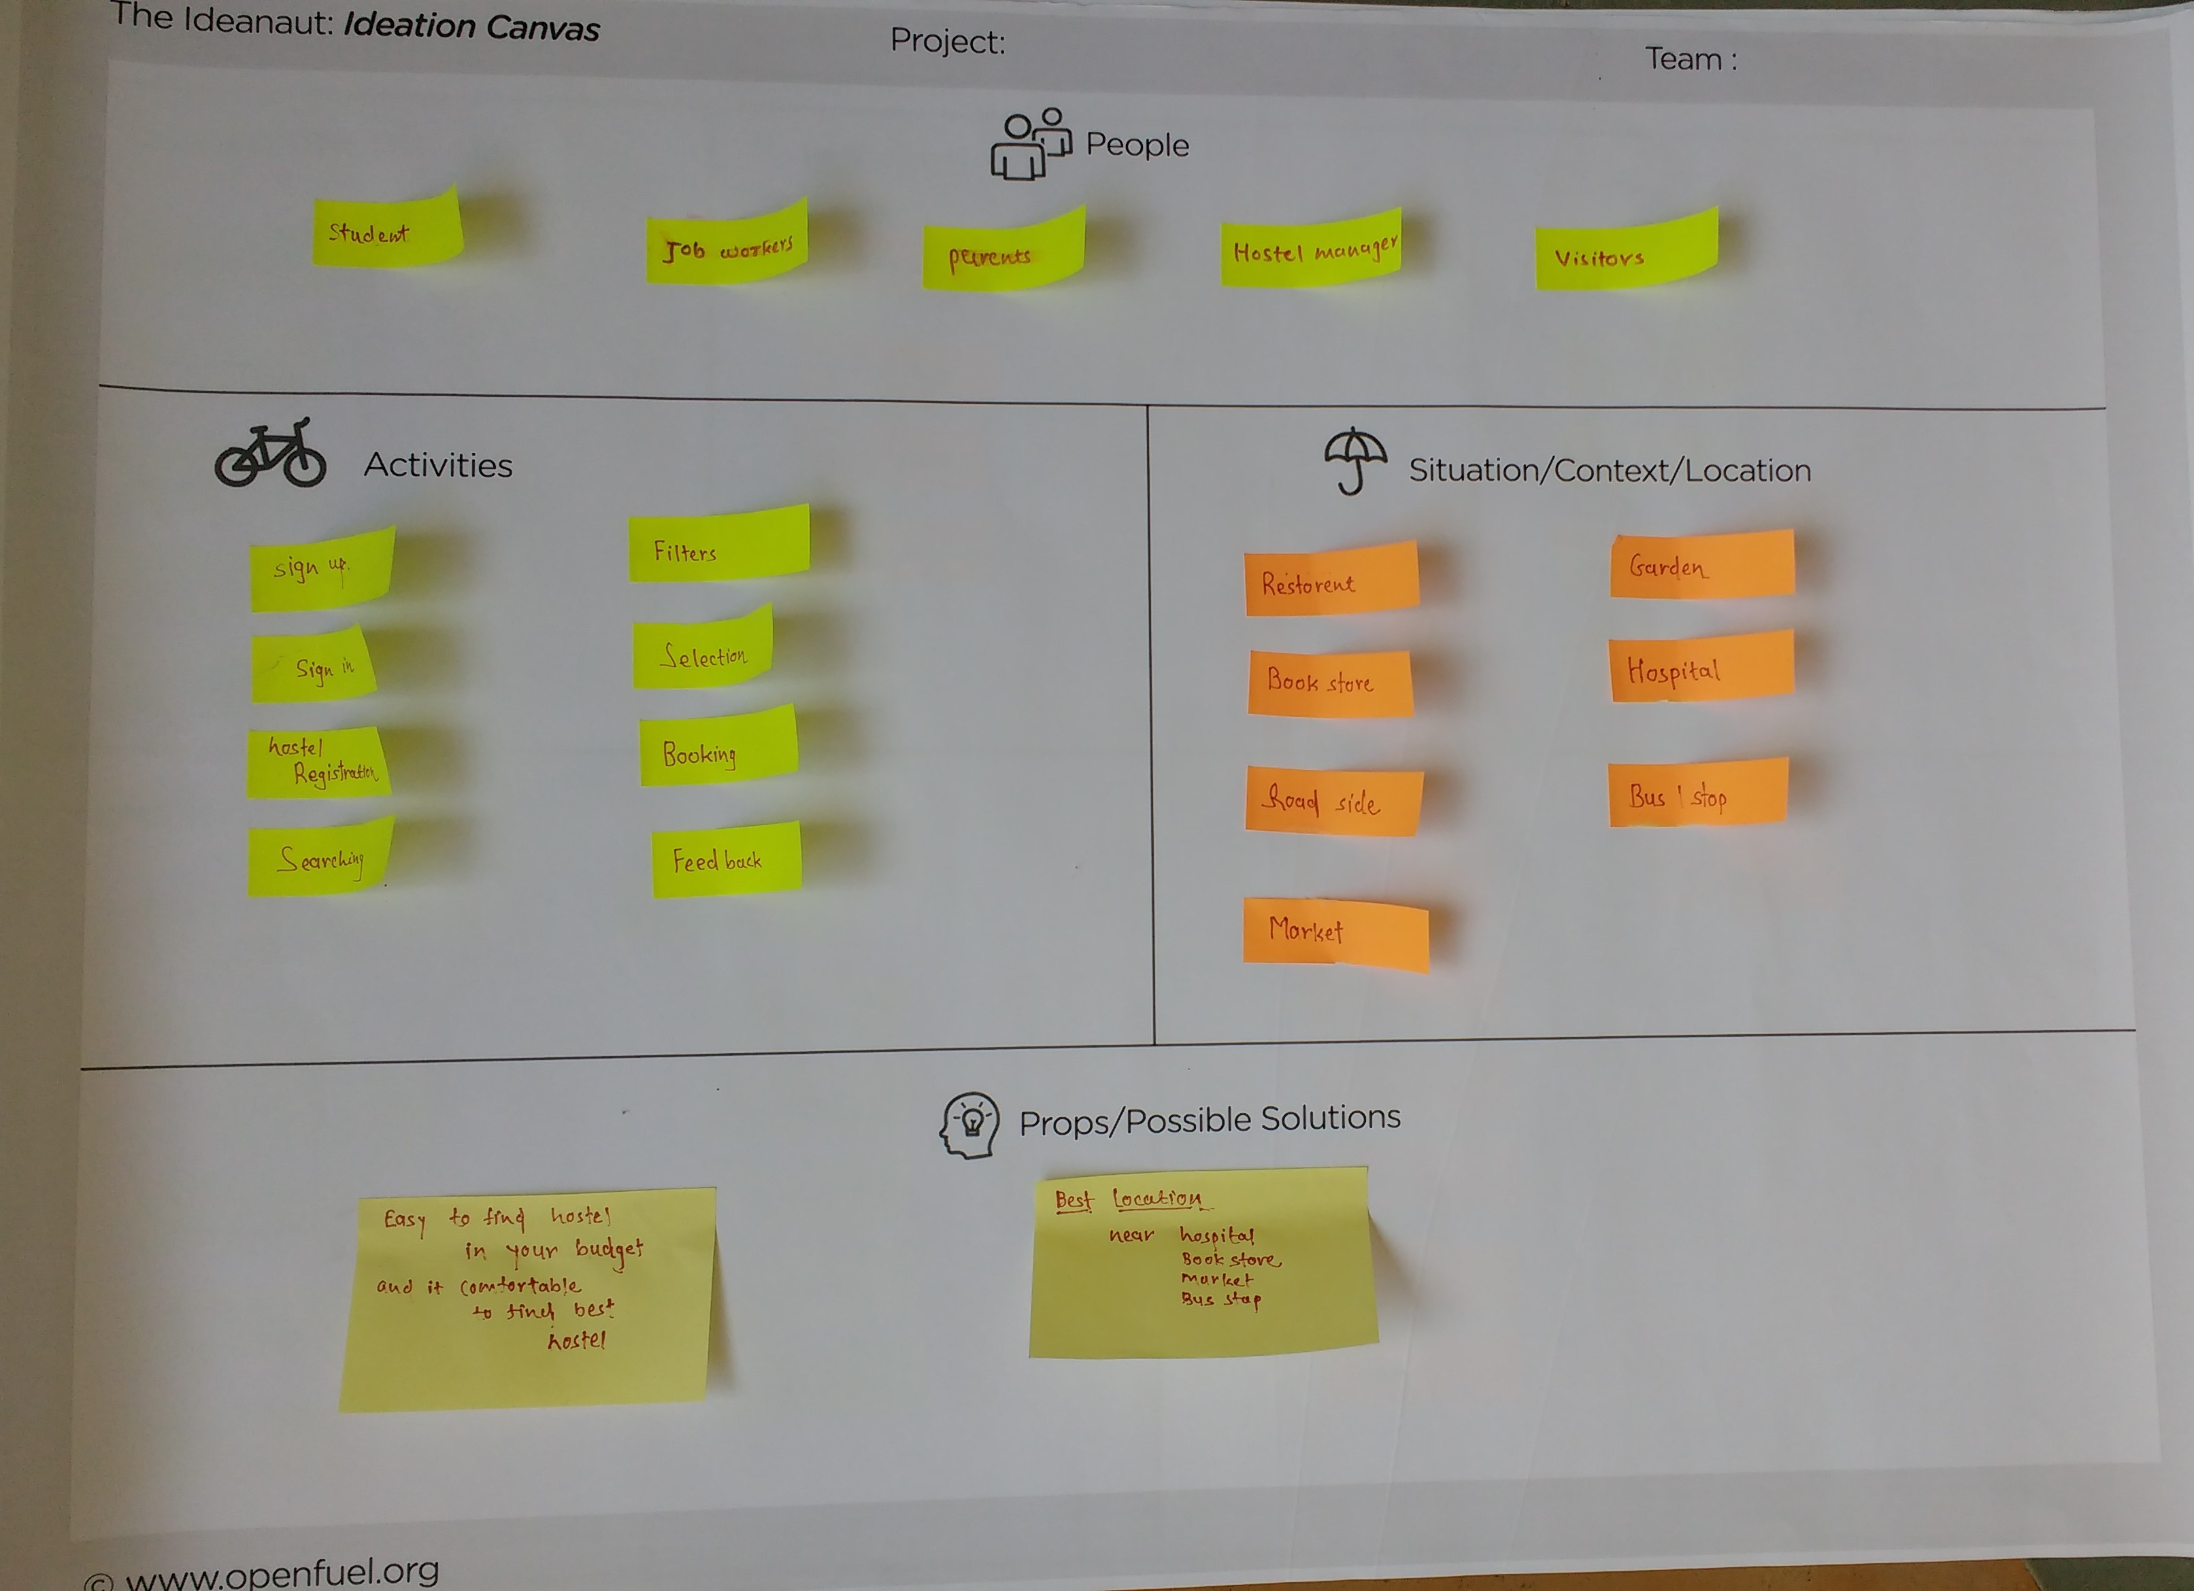

**Fig.2.2.3**

* People
  + - Actual students
    - Job employees
    - Hostel workers
    - Visitors, Parents
* Activities
  + Registration activities
    - * Log in
      * Generate password
      * Log out
      * Registration by unique id
  + Hostel related activities
    - * Find hostels
      * Inquiry
      * View status of current hostel students
      * Give details about your hostels and review it
* Props/possible solution
  + - Workload reduces of finding hostels across the city
    - Online status update of hostel students
    - Online storage of database
    - Contact details of hostels are available
    - Users can easily review their hostel
    - Information about facilities that hostel are providing and lacks to deliver it
* Situation/context/location
  + - Schools, Colleges, Tuition classes
    - Provision stores
    - Gardens
    - Temples
    - Hotels that provides quick snaks
    - Tea or coffee store

**2.2.4 PRODUCT DEVELOPMEN CANVAS IMAGE AND DESCRIPTION**

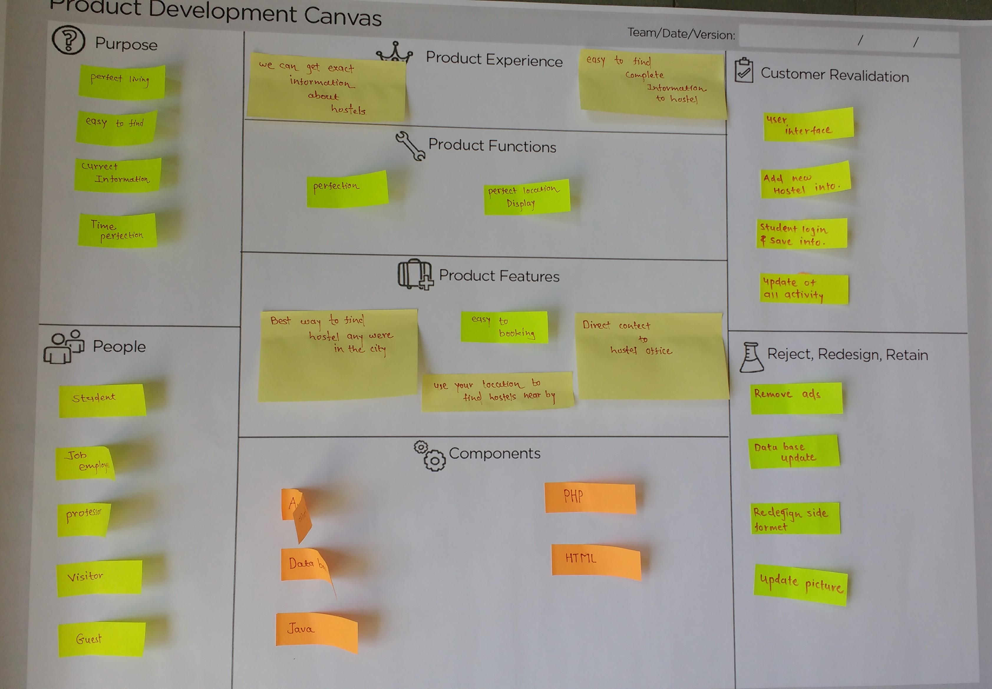

**Fig.2.2.4**

* Purpose
  + - Better storage of all hostels available across the city
    - Citizen can find hostels online
    - To provide help
    - To preserve valuable time of citizen
    - Provide correct info.
* People
  + - Citizens
    - Visitors, Parents
    - Students, Job employees
* Product function
  + - User friendly
    - Manage hostels record easily
    - Secure and better
    - Current photos are also available
* Product features
  + - Registration by unique ID
    - Communication became easy between citizen and hostel managers
    - Info is also available about our city hostels
    - Only verified hostels by My Hostel team will be available
    - Hostel status is update frequently
    - Registered users can easily give their reviews about the hostel they started living
* Components
  + - Android studio
    - Laptop
    - External storage device
    - Oracle
    - Mobile phone
    - Operating system
    - Hostinger
    - Google maps
    - Desktop computer
    - HTML editor and notepad++
* Customer revalidation
  + - Concern about real life reviews of current hostels students
    - Registration should be done by verified email IDs
    - Registration of users is must

**2.3 Summary of Findings of Prior Art Search of the Project**

Prior art is any evidence that your invention is already known. Prior art does not need to exist physically or be commercially available. It is enough that someone, somewhere, sometime previously has described or shown or made something that contains the use of technology that is very similar to your invention or project. While looking for prior art, you should also look for competing art. These are ideas that may not be at all like yours but do the same job. It is important to study competing art for two reasons:

* Most inventions are a solution to a problem and most problem have more than one possible solution. You need to examine other solutions, as some may offer more advantages than yours.
* If you try to exploit your idea commercially, alternative solution may be strong competition. In order to argue successfully that your solution is better than alternatives, you need to know what the alternatives are!

**2.3.1 Summary of Two Survey /Research Paper Prepared by Utsav Ardeshana**

* Main Problem is the common people doesn’t know about apps that provides online reviews of hostels.
* Common people is mostly used PGs or anything else.
* Other online apps like Justdail is not fully trusted by people so the people is not using them.
* Many of people not known system of BRTS, work of BRTS & how to buy a ticket.
* We provide all the information of desired hostels so more & more people can get actual information about hostels.

**2.3.2 Summary of Two Survey /Research Paper Prepared by Hiten Bhayani**

* We take a survey on Govani hostel.
* In this survey we meet a various people like student, teacher, worker, old women & shopkeeper who already travelling daily in Govani hostel and ask some basic questions.
* By those question we find out that many problems that exits there and which is people facing in their day to day life.
* By the survey we find out many of people is not known the benefits of online hostel apps that gives you overview of knowing your future hostels before even starting living there.
* We took out the list of problems that we could work out to fix, to make online hostel booking apps more trustworthy.

**2.3.3 Summary of Two Survey /Research Paper Prepared by Darshan Chavda**

* My research work is on the availability of data on popular hostel booking site.
* Many popular websites have tons of database about availability of hostel across the globe including many popular cities.
* But what to do with small towns, like Rajkot?
* Local websites like Justdail.com gives some useful information about the available hostels list across the city.
* But they fail to deliver photos of desired hostels and sometime they even don’t provide proper contact details to know actually if there is availability of room at hostel.
  1. **Short Summary of the learning from Reverse Engineering Activity**

The term reverse engineering as applied to software means different things to different people, prompting Cross to write a paper researching the various uses and defining taxonomy. From their paper, they state, Reverse engineering is the process of analyzing a subject system to create representations of the system at a higher level of abstraction. It can also be seen as going backwards through the development cycle. In this model, the output of the implementation phase (in source code form) is reverse-engineered back to the analysis phase, in an inversion of the traditional waterfall model.

Reverse engineering is a process of examination only: the software system under consideration is not modified (which would make it re-engineering). Software anti-tamper technology is used to deter both reverse engineering and re-engineering of proprietary software and software-powered systems. In practice, two main types of reverse engineering emerge. In the first case, source code is already available for the software, but higher-level aspects of the program, perhaps poorly documented or documented but no longer valid, are discovered. In the second case, there is no source code available for the software, and any efforts towards discovering one possible source code for the software are regarded as reverse engineering. This second usage of the term is the one most people are familiar with. Reverse engineering of software can make use of the clean room design technique to avoid copyright infringement.

On a related note, black box testing in software engineering has a lot in common with reverse engineering. The tester usually has the API, but their goals are to find bugs and undocumented features by bashing the product from outside. Other purposes of reverse engineering include security auditing, removal of copy protection(cracking), circumvention of access restrictions often present in consumer electronics, customization of embedded systems (such as engine management systems), in-house repairs or retrofits, enabling of additional features on low-cost crippled hardware (such as some graphics card chip-sets), or even mere satisfaction of curiosity.

# CHAPTER 3

Phase -2 Pre-Design (Learning Need Matrix - LNM)

**3.1 Summary on learning needs by students in the 4th Semester shall be included in report with allocation of learning requirements among the members of the group**

Learning Needs Matrix will help students to identify the learning requirements at an early stage along with prioritization of specific learning along with defined time duration for each learning priority. Identification will be focused on listing out both (i) the learning, which is included in some subject of the formal syllabus of your branch and (ii) the learning, Summary on learning needs by students in the 4th Semester shall be included in report with allocation of learning requirements among the members of the group which is required for solving the Design problem and which may not be included in the formal syllabus of the other subjects. All such learning, required for developing the product, should be considered to be required to be studied for the group of students, who are working on the product. It may include learning specific skills.

In 4th semester our group member will learn the subject operating system, object oriented programming with c++ and computer networks which will help us to develop our application. Some specific concepts will help us to understand the problem of higher level semester. As our group is making application in Python, concept of OOP will help us to learn Python language and its working. Computer Network helped to understand how we can use networking with our application project. Operating system is basic of our android based system. This is all which is required learning needs in the 4rth semester by us.

**3.2 LNM** **Sheet image and description:**

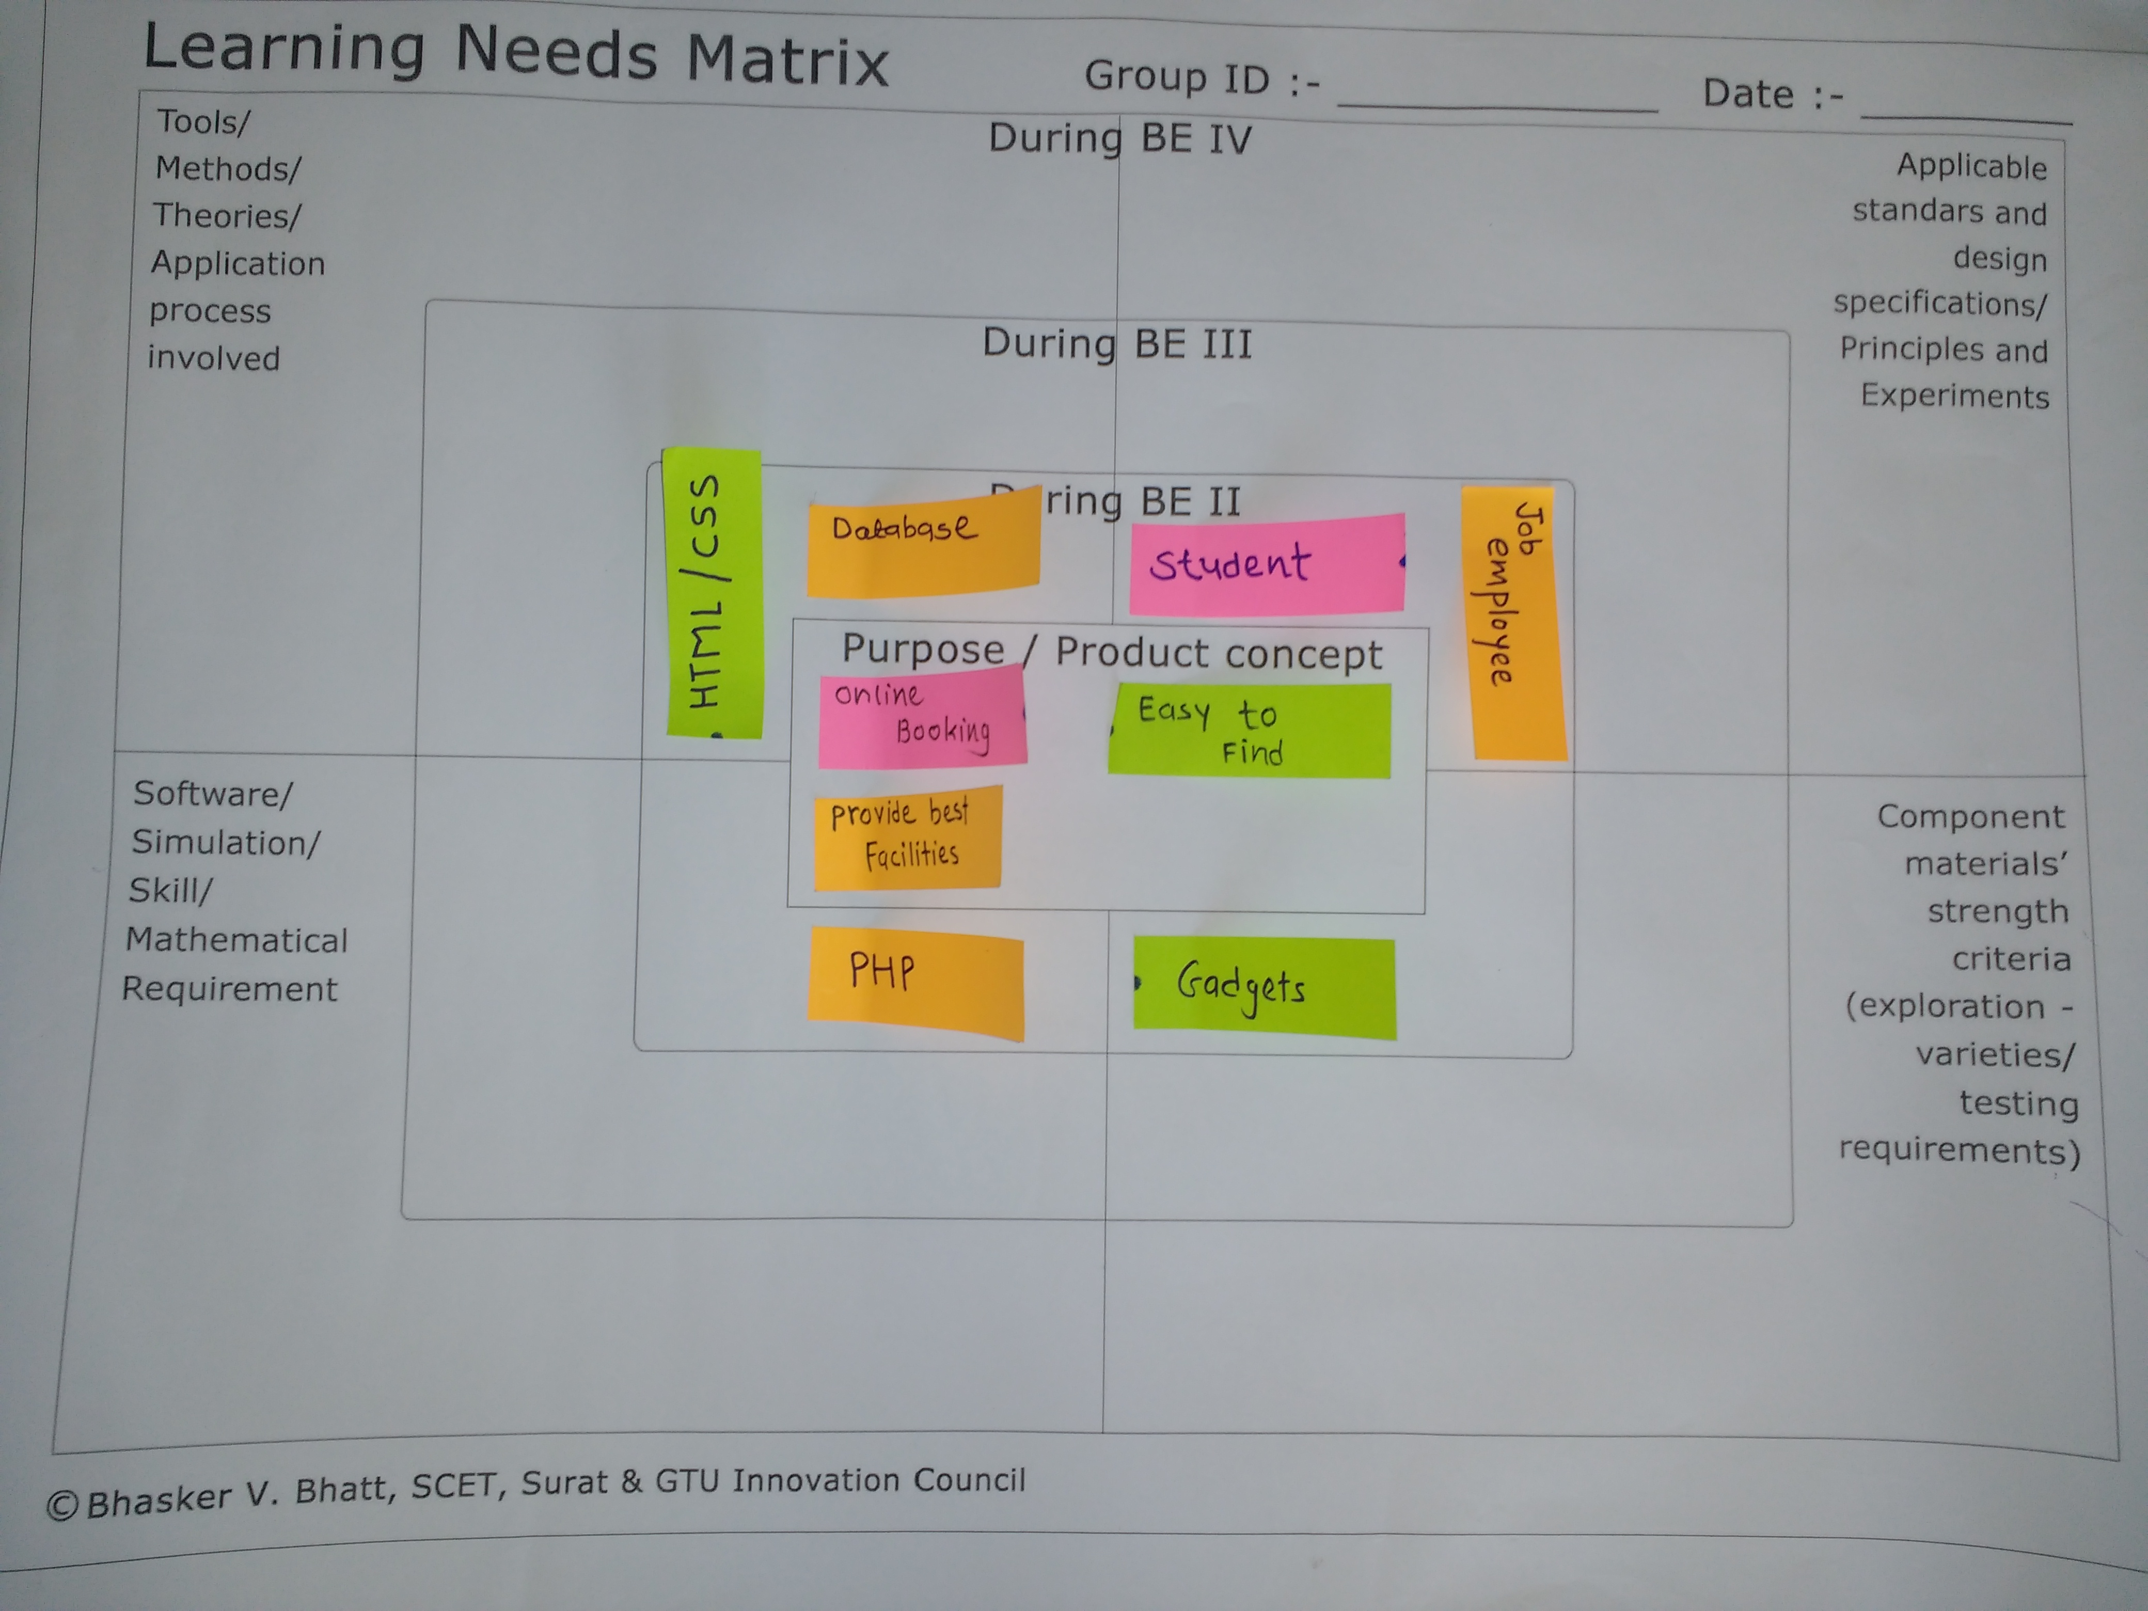

**Fig.3.2 Learning Needs Matrix**

* Purpose/Product Concept:
* Better storage for all hostel details
* To provide contact details of all the hostels of the city
* Citizens can easily find hostels from anywhere
* To preserve time of citizen by reducing time and money spend on finding hostels
* Tools/Methods/Theories/Application process involved:
* Made Prototype
* Jason (connectivity tool)
* Software/Simulation/Skill/Mathematical/Requirement:
* Android
* HTML, PHP
* JDK
* SDK
* ADBD driver
* Hostinger database
* Applicable standards and design specifications/Principles and Experiments:
* Applicable for all types of students
* User can find hostels easily
* User can read current hostel students reviews
* Component materials’ strength criteria (exploration-varieties/testing requirements)
* Google maps
* Internet connection
* Photoshop for logo design
* Mobile phones
* Laptop

# *CHAPTER 4*

**Phase- 3 Rough Prototype Model / Conceptual Plan-Layout**

**4.1 Image of your Rough Prototype / Conceptual Plan-Layout & Description:**

Description:

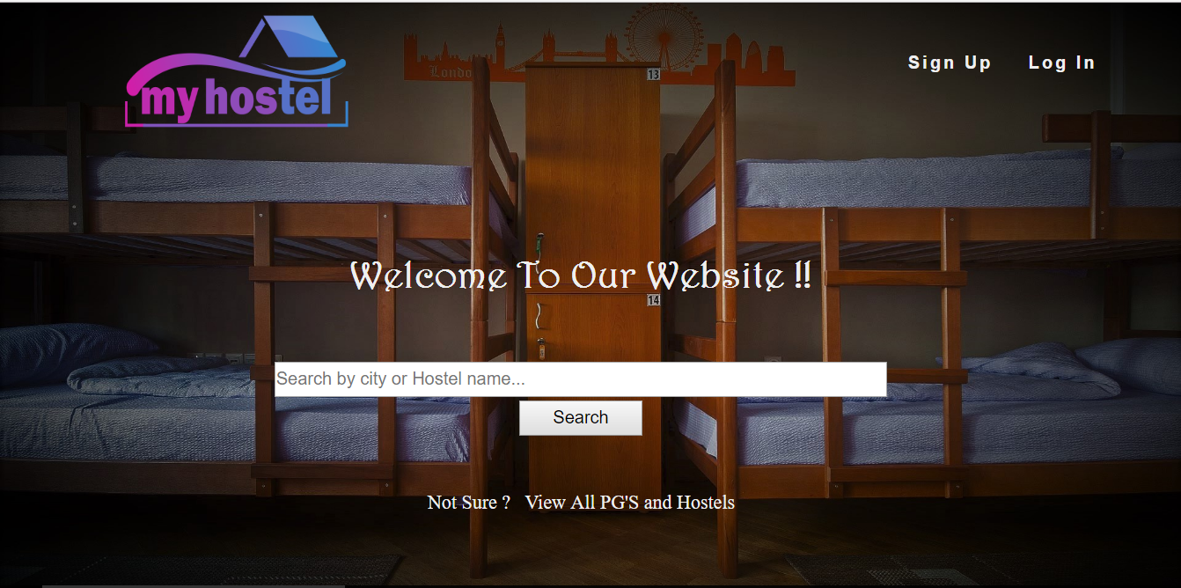

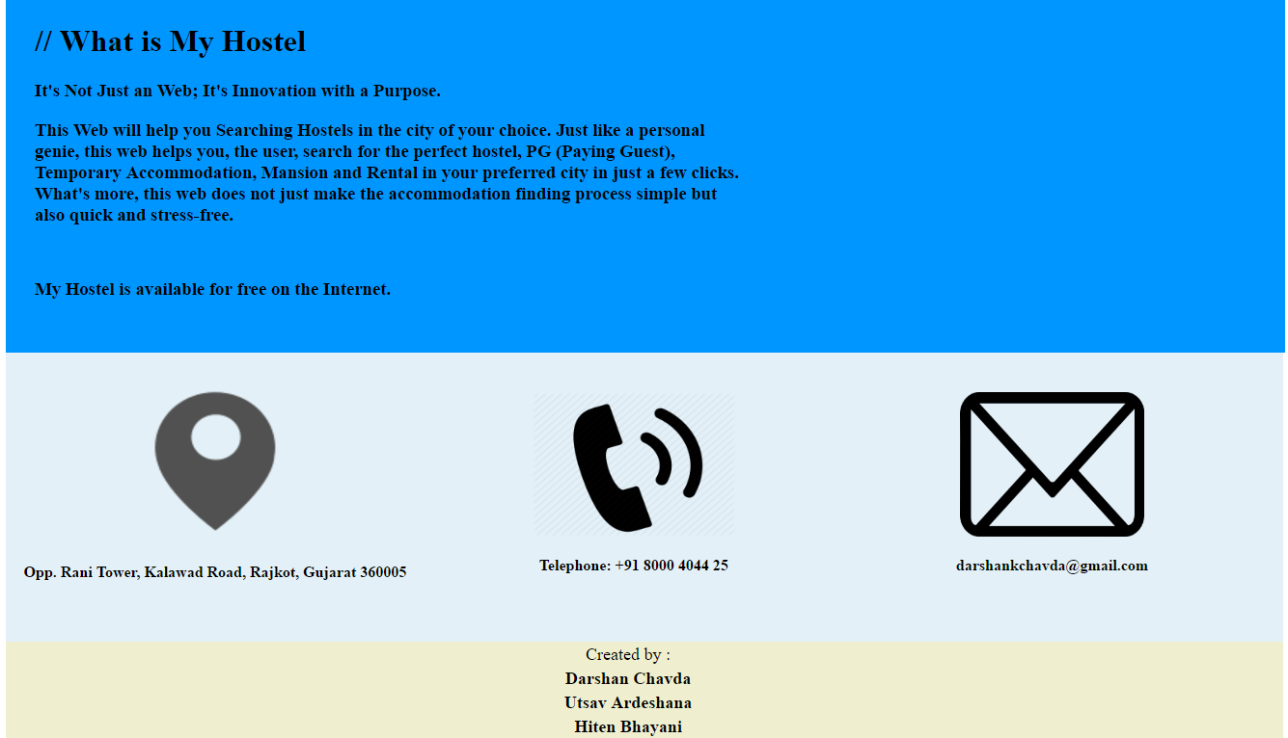

**[Figure 4.1.1 Home screen]**

In this first of all when we open the website the first page is the homepage. We can see all the things which are in our website.

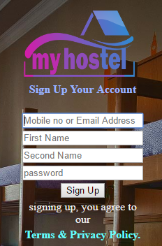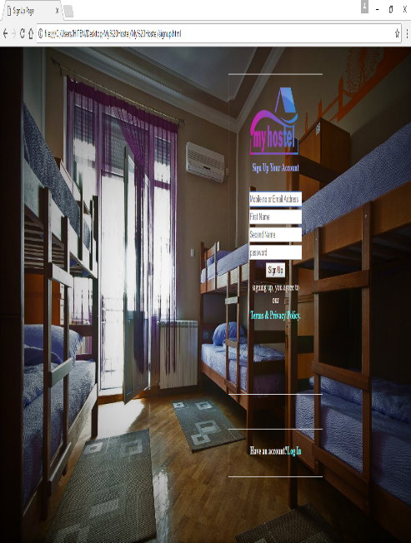

**[Figure 4.1.2 Registration screen]**

When any user opens this application first time for this user one option is registration if you are new user at home page. User have to fill up this form to enter the website first time.

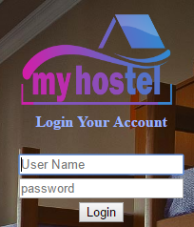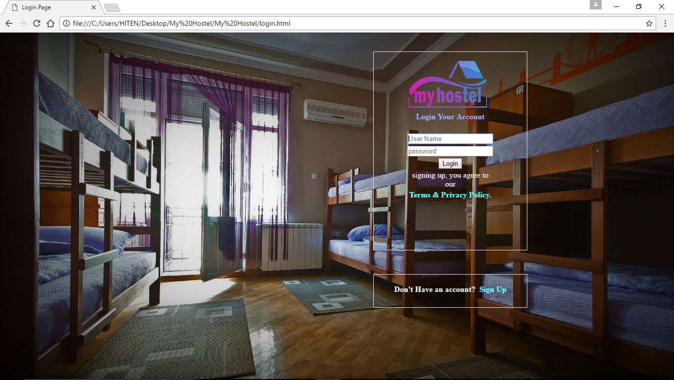

**[Figure 4.1.3 Login screen]**

In this page user need to enter their email id and password. This is for security purpose to make sure nobody misbehaves with the data of website.

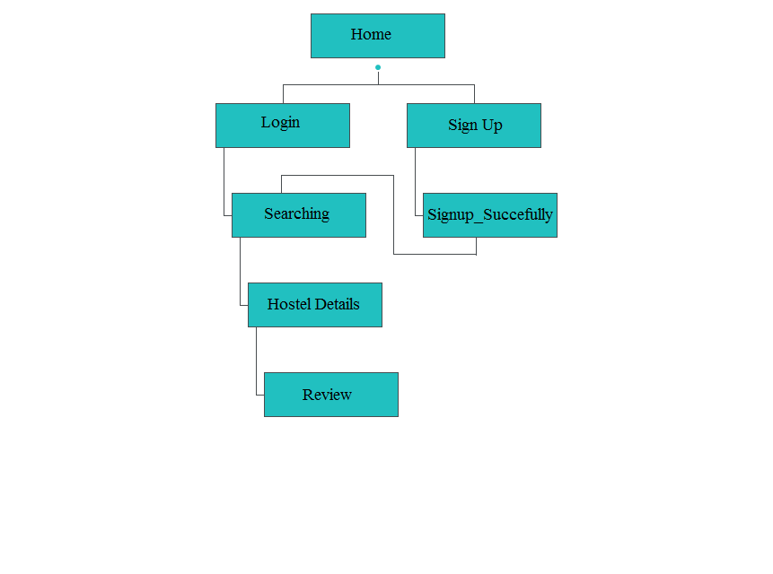

**[Figure 4.1.7 Sitemap]**

This is the flowchart of our application. This shows how our application is working step by step.

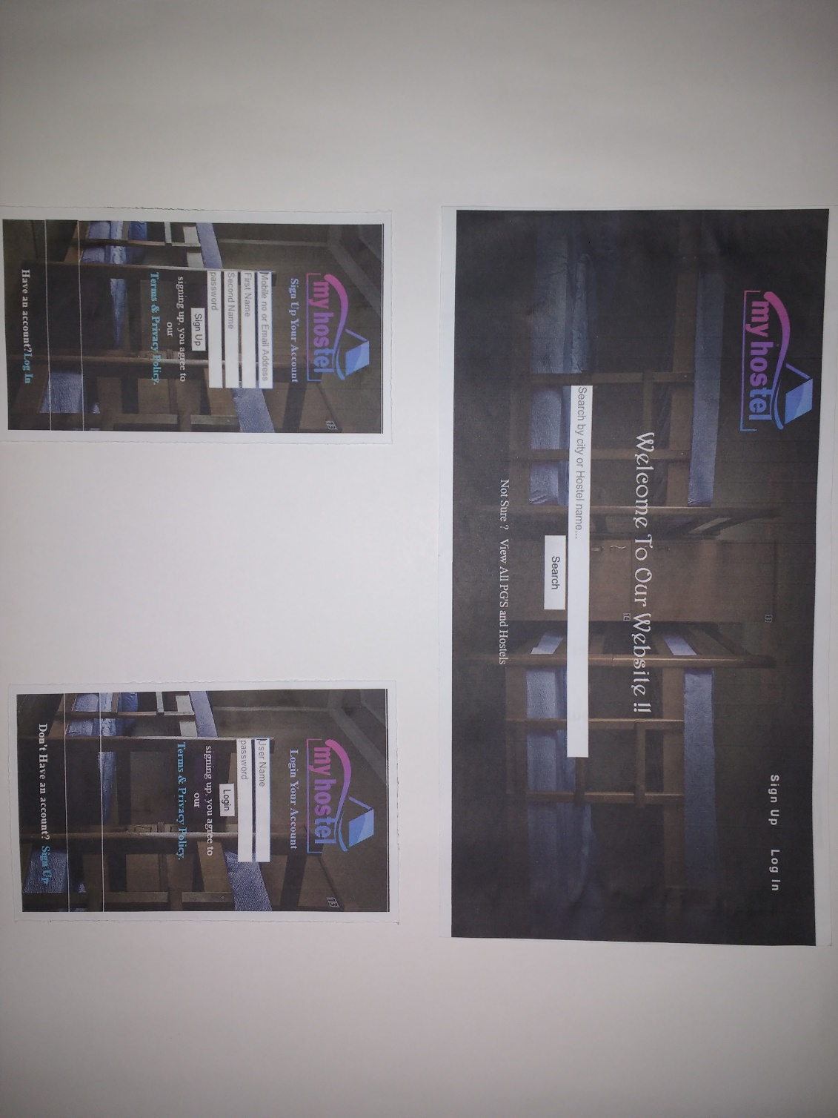

**[Fig.4.1.8 Prototype]**

**5.1 CONCLUSION**

**-** It has been a wonderful and learning experience for me while working on this project. This project has been taking me through the various phases of project development and gave me real insight into the world of software engineering. The joy of working and the thrill involved while tackling the various problems and challenges gave me a feel of developer’s industry.

- From a proper analysis of positive points and constraints on the component, it can be safely concluded that the product will be a highly efficient GUI based component. This application will be working properly and meeting to all user requirements. This component can be easily plugged in many other systems. This project is further extendable**.**

**5.2 REFERENCES**

* [**http://**](http://www.w3schools.com/php/php_mysql_intro.asp) [**www.w3schools.com/php/default.html**](http://www.w3schools.com/php/default.html)
* **http://** [**www.w3schools.com/js/default.html**](http://www.w3schools.com/js/default.html)
* **http://** **www.w3schools.com**
* [**https://en.m.wikipedia.org/wiki/**](https://en.m.wikipedia.org/wiki/Real_estate)
* [**http://stackoverflow.com/**](http://stackoverflow.com/)
* [**https://www.youtube.com/**](https://www.youtube.com/)
* **http://** **www.w3schools.com/css/default.html**